

**CSE 499 WEEKLY JOURNAL**

**Name and Student ID:** Mohammad Navid Nayyem (172014003)

**Project Title:** Dhaka Traffic Detection

**Project Start Date:** 07-11-2020

**Team Members:** KH. Nafiu Nur Rashid (172014026), Fabliha Bushra (163014029)

**Supervisor:** Mohammad Rifat Ahmed Rashid

|  |  |  |  |
| --- | --- | --- | --- |
| Week | Date  (From-To) | Works Done | Supervisor’s Evaluation |
| **29th** | 02/06/2021 to 08/06/2021 | * **Continuation from previous week**   Our supervisor gave some feedback to write those incomplete points in final paper. We wrote those incomplete points in final paper and send it again to our supervisor for final check.   * **New Work done in this week**   We have created our presentation slide for CSE499 Final Defense and send it to our respective supervisor.   * **Future Implications**   We have developed a fully functioning Android app to detect the vehicle classes perfectly from videos, images or live videos through mobile camera. | * Satisfactory * Needs Improvement   Comments: |

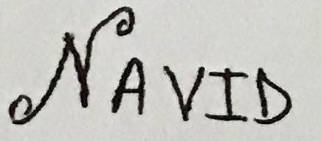

Signature of Student Signature of Supervisor